**Introduction to Web Applications**

**Introduction**

This module is your first step in starting web application pentesting. It teaches important aspects of web applications, which will help you understand how web application pentesting works.

Module Summary

This module is your first step in starting web application pentesting. It teaches important aspects of web applications, which will help you understand how web application pentesting works.

The goal for the assignment is aligned to:

* Learn the fundamentals of web technologies, including HTTP, HTML, CSS, and JavaScript.
* Understand the basics of web servers, web applications, and databases.
* Gain familiarity with web security concepts, such as cross-site scripting and SQL injection.
* Learn to identify and exploit common web vulnerabilities using penetration testing tools.

This module will cover the following topics:

Intro to Web Applications

* Intro to Web Applications
* Web Application Architectures
* Front-end vs. Back-end
* Front-end Components
* HTML
* CSS
* JavaScript
* Front-end vulnerabilities
* Data Exposure
* HTML Injection
* XSS/CSRF
* Back-end Components
* Back-end Servers
* Web Servers
* Databases
* Development Frameworks & APIs
* Back-end vulnerabilities

Public Vulnerabilities

Common Web Vulnerabilities

The following are also some of the covered topics:

What is a web application?

What are the common web application architectures?

What are the most common web servers, and what are the advantages of each?

What types of databases are there, and where is each one used?

Common Web Application Development Frameworks

What are APIs, and how are they used?

Public Web Application vulnerabilities

Intro to OWASP Top 10 for Web Applications

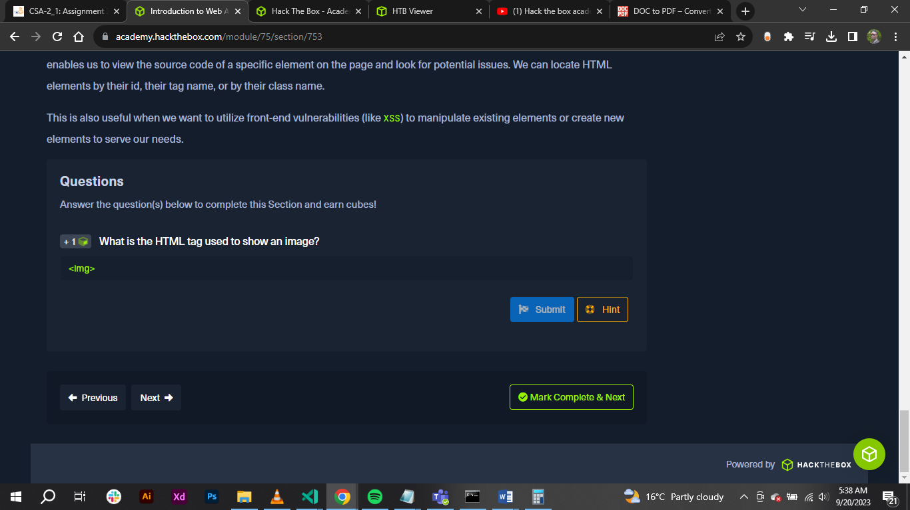

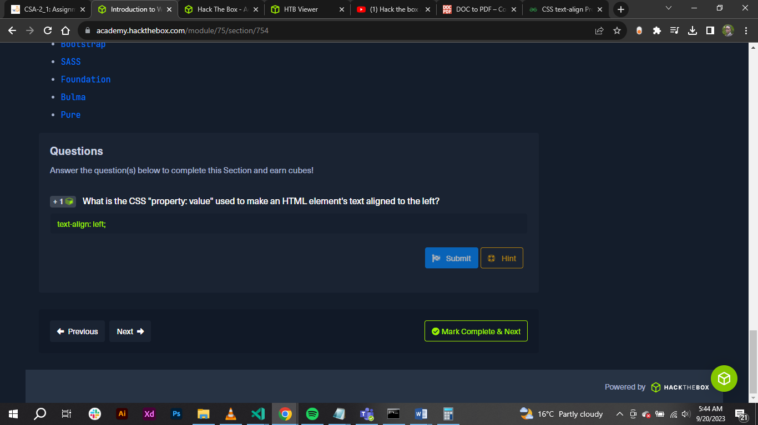

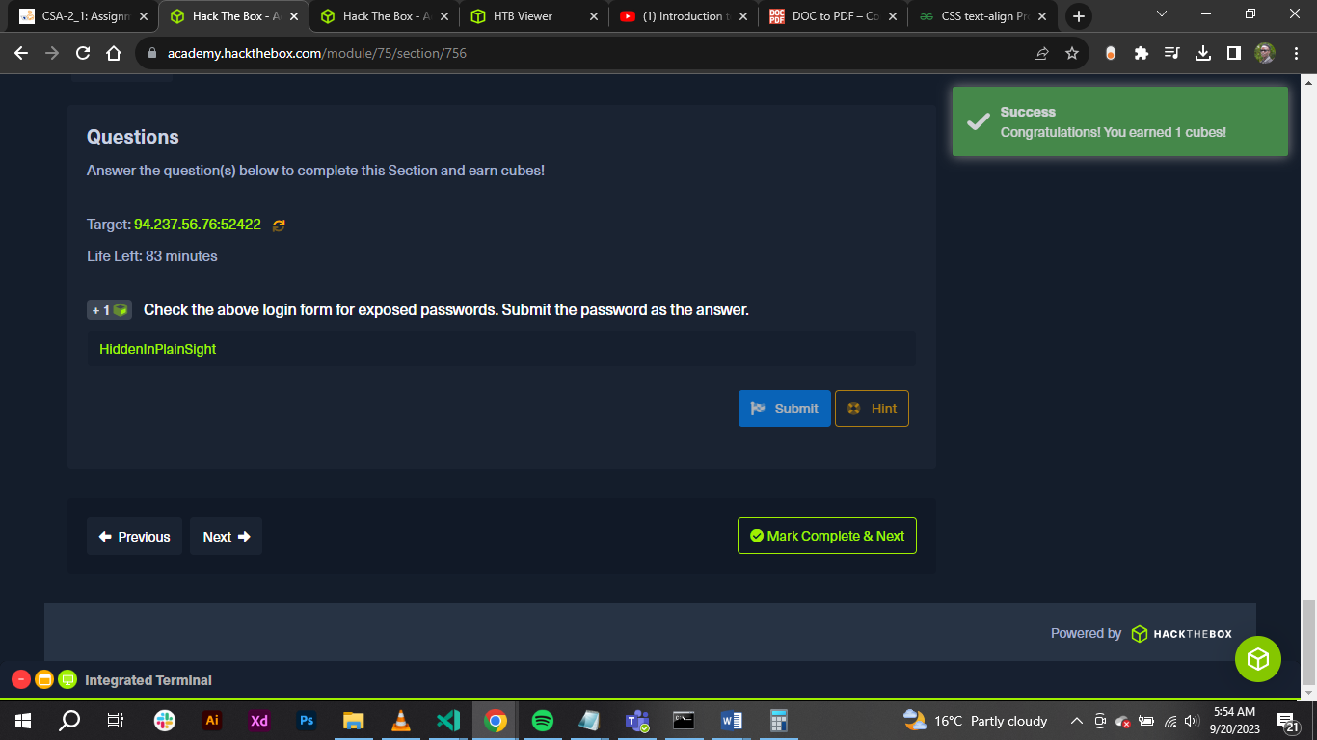

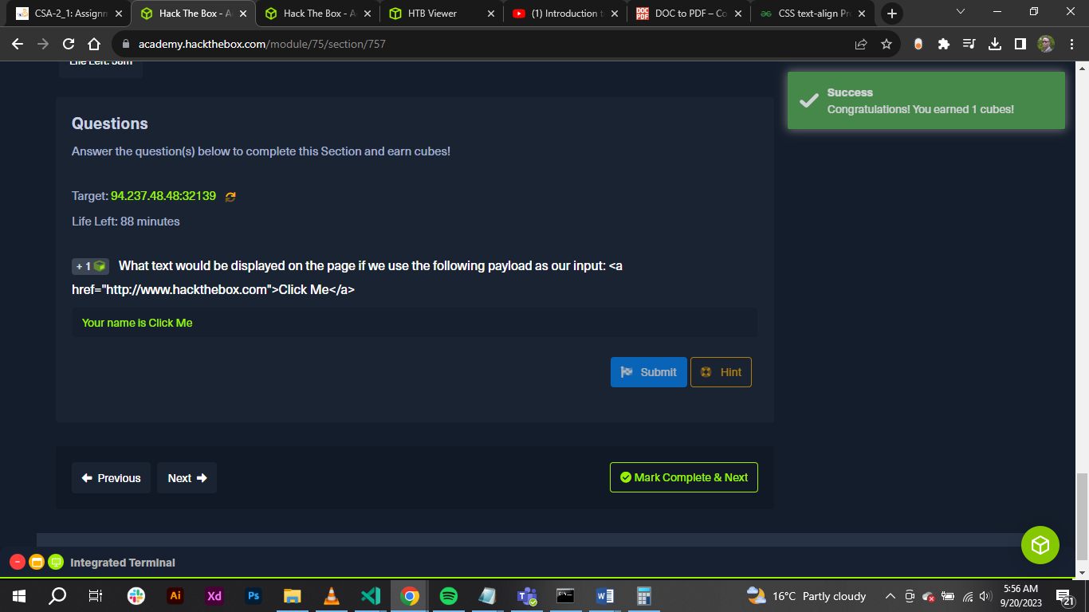

**Conclusion**

* Learnt the fundamentals of web technologies, including HTTP, HTML, CSS, and JavaScript.
* Understood the basics of web servers, web applications, and databases.
* Gained familiarity with web security concepts, such as cross-site scripting and SQL injection.
* Learnt to identify and exploit common web vulnerabilities using penetration testing tools.